|  |
| --- |
| **Заказчик:** |
| **Имя:** |
| **Телефон:** |
| **Почта:** |



|  |
| --- |
| **ООО «Авиком-Пласт»**  Россия, г. Волгоград, 400011,  ул. Электролесовская, 35,  Тел.: 8 (8442) 49-36-31 |

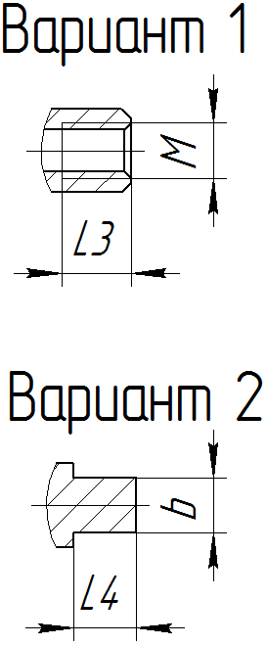

**Опросный лист для заказа конвейерных роликов**

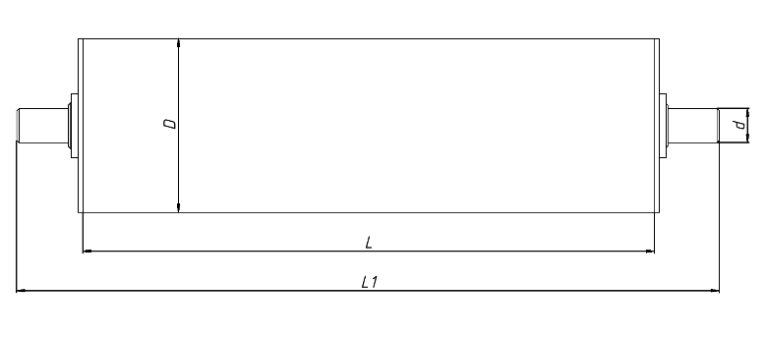

|  |  |  |
| --- | --- | --- |
| 1. Внутренняя резьба | 2. Наружняя резьба | 3. Лыска двухсторонняя |

|  |  |
| --- | --- |
| 4. Лыска двухсторонняя глухая | 5. Шестигранная |

|  |  |  |  |  |  |  |  |  |  |  |  |
| --- | --- | --- | --- | --- | --- | --- | --- | --- | --- | --- | --- |
| **Исполнение оси** | **D** | **L** | **L1** | **d** | **l** | **S** | **M** | **SW** | **Материал** | **Подшипник** | **Кол-во** |
|  |  |  |  |  |  |  |  |  |  |  |  |
|  |  |  |  |  |  |  |  |  |  |  |  |
|  |  |  |  |  |  |  |  |  |  |  |  |

**Дополнительная информация:______________________________________________________________________________________________________________________________________________________________________________________________________**